DAA LAB — GRAPHS AND VISUALIZATIONS
Question: Generate graphs and visualizations comparing execution time and memory consumption of sorting and Fibonacci algorithms. Include appropriate observations.
Code
import time
import tracemalloc
import random
import matplotlib.pyplot as plt

# Use the sorting functions from sorting_algorithms.py
from sorting_algorithms import (
bubble_sort, selection_sort, insertion_sort,
merge_sort, quick_sort, heap_sort
)

input_sizes = [100, 500, 1000]
# times and memory store the measured values
# for sorted, reverse-sorted and random inputs

# The experiment records execution time with time.perf_counter()
# and peak memory with tracemalloc.get_traced_memory().

# Graphs are generated with plt.plot().
Time Complexity Graph — Sorting

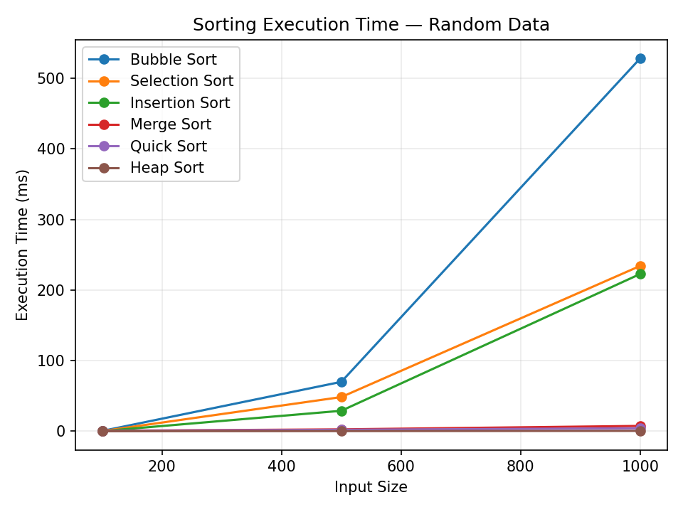
Observation: As input size increases, Bubble, Selection and Insertion Sort show faster growth than the O(n log n) sorting algorithms.
Input Condition Graph — Sorting

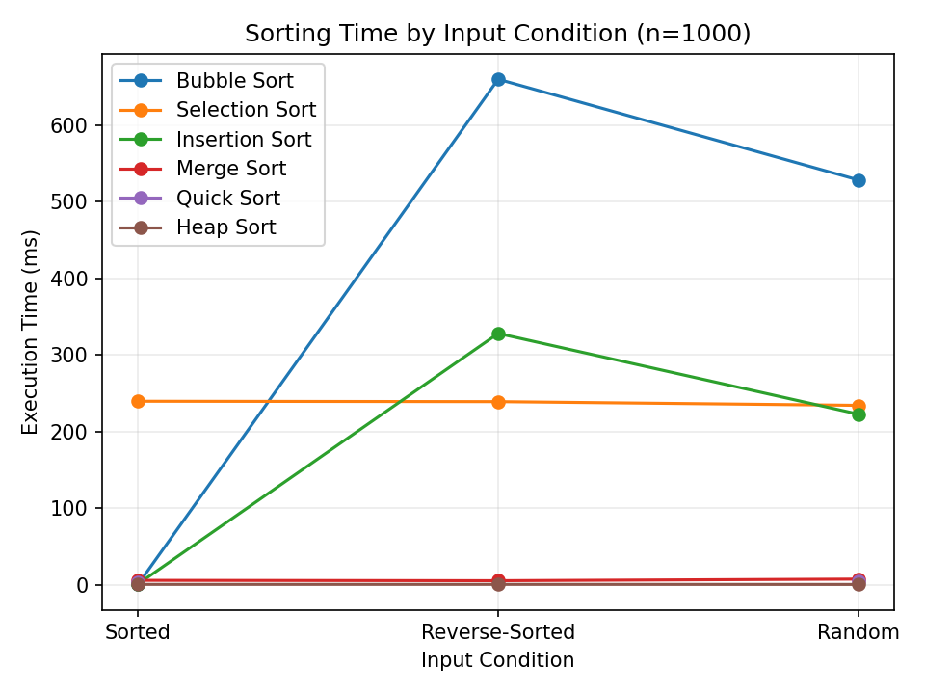
Observation: Sorted input is favorable for Bubble and Insertion Sort. Reverse-sorted input is generally more expensive for quadratic algorithms.
Fibonacci Execution Time

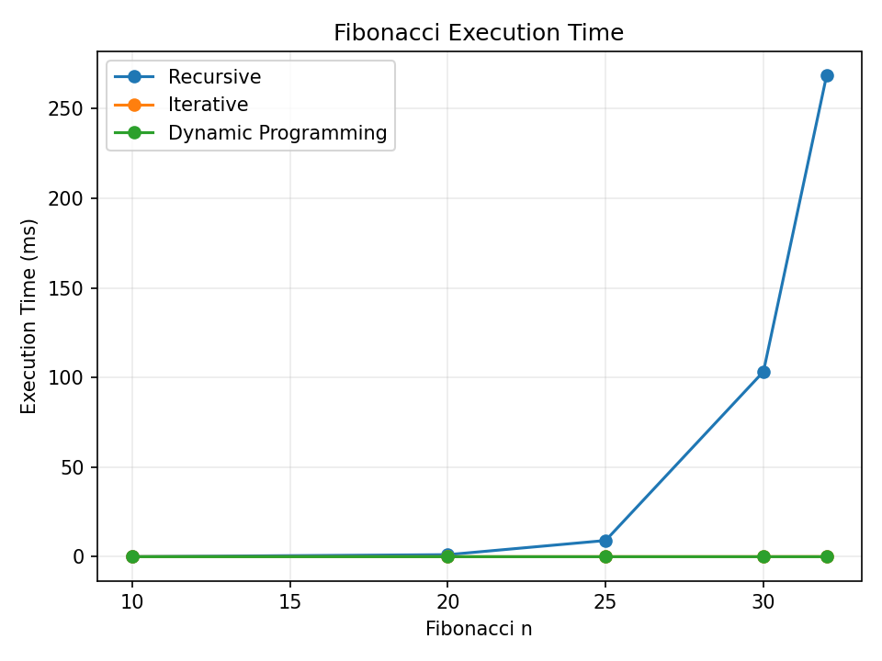
Observation: Recursive Fibonacci becomes rapidly slower as n increases, while Iterative and Dynamic Programming remain approximately linear.
Space / Memory Usage

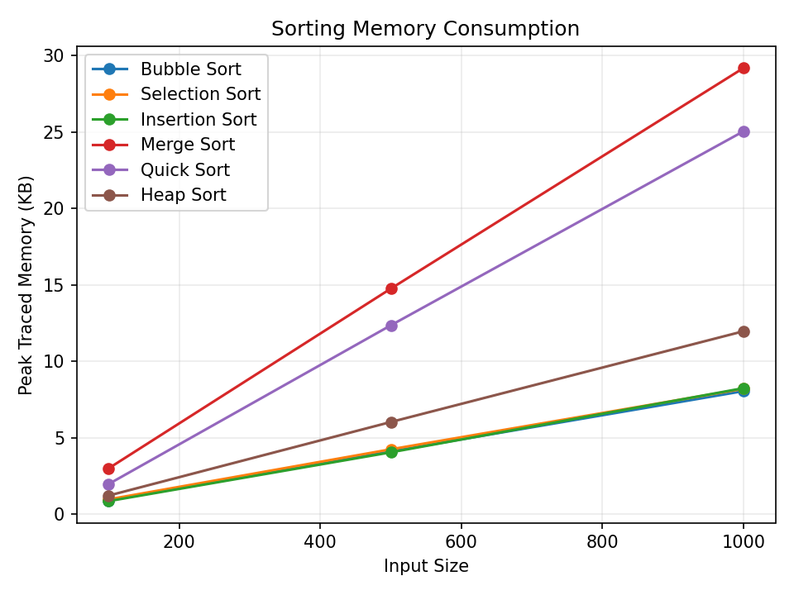
Observation: Measured Python memory reflects list copies and temporary structures, so practical memory can differ from textbook in-place space complexity.
GitHub Link
____________________________________________
Paste the GitHub repository/file URL after uploading the Python code.

